Project VI

Neil P. Parmar

Dept. of Electrical Engineering and Computer Science

Oregon State University, Corvallis, USA

parmarn@oregonstate.edu

1. Introduction

The particular project uses the functionality of OpenCL has been categorized to test the its performance using the array multiplication, the array-multiplication & add and finally multiply reduction. The particular report firstly explains about the System Configurations and relevant details, then it explains various Implementation Specifications and finally discusses about the performance with respect to various tabular and graphical representations.

1. System Configurations & Load

This project was implemented using rabbit at OSU on-campus computer labs which has about 32 CPU cores. Fig 1 demonstrates the detailed system configuration for reference.

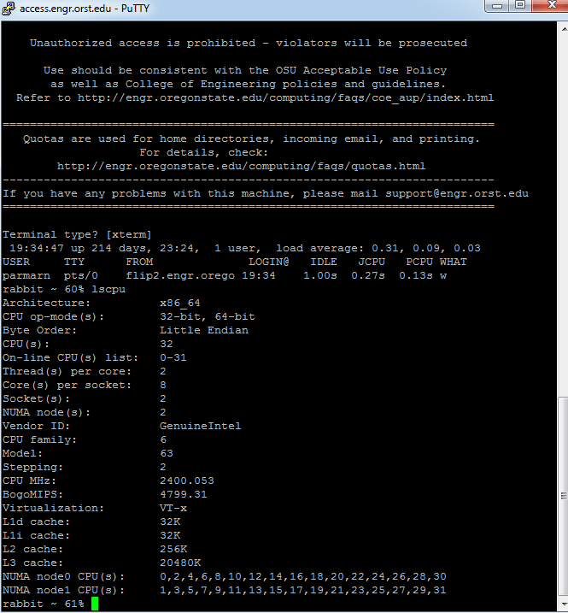

Fig 1. System configurations

1. Implementation Specifications

The particular project has been categorized into three sections namely First, Second and Third folders respectively. The First folder implements the features of Multiplication, the Second folder implements the features of Multiplication Add and the third section implements the features of Multiply Reduce. The main implementation code is found under the file name first.cpp and first.cl demonstrating different functionality under the categorized folders respectively.

1. Performance and Speedup
2. Multiplication Performance (MegaMultiplies/sec)



Table I above represents the performance of Array Multiplication which is measured in MegaMultiplies/sec. The Global Work Size ranges from 1K to 8192K measured across the Local Work Size of 8, 16, 32, 64, 128, 256 and 512 respectively. The graphical representation of the table is shown in Fig 2 below. Here the performance varies with respect to the selected Local Work Size, where for Local work size of 8 shows a particularly low, but constant performance while the highest performance is observed with a local work size of 512. The performance increases steeply with the lower values of the Global work size and then it almost becomes constant (but gradually increasing) with the increase in the particular work size.

Fig 3 demonstrates the performance of Table I with a transpose representation of the graph in Fig 2. Here the performance is particularly observed with the respect to the Global Work Size while the horizontal axis represents the varying amount of the Local Work Size. From the particular figure it can be concluded that for Array Multiplication using OpenCL, the highest performance gain is observed the Global work size of 8192. Moreover, from the particular figure it can be observed that the performance is levels to a constant (while gradually decreasing) for lower values of Global Work Size. Also, the performance spikes can be observed for lower values of Local work size, while almost leveling out (remaining constant but gradually increasing) with the increase in the particular work size.

These have been demonstrated with respect to Table I, Fig 2, and Fig 3 respectively.

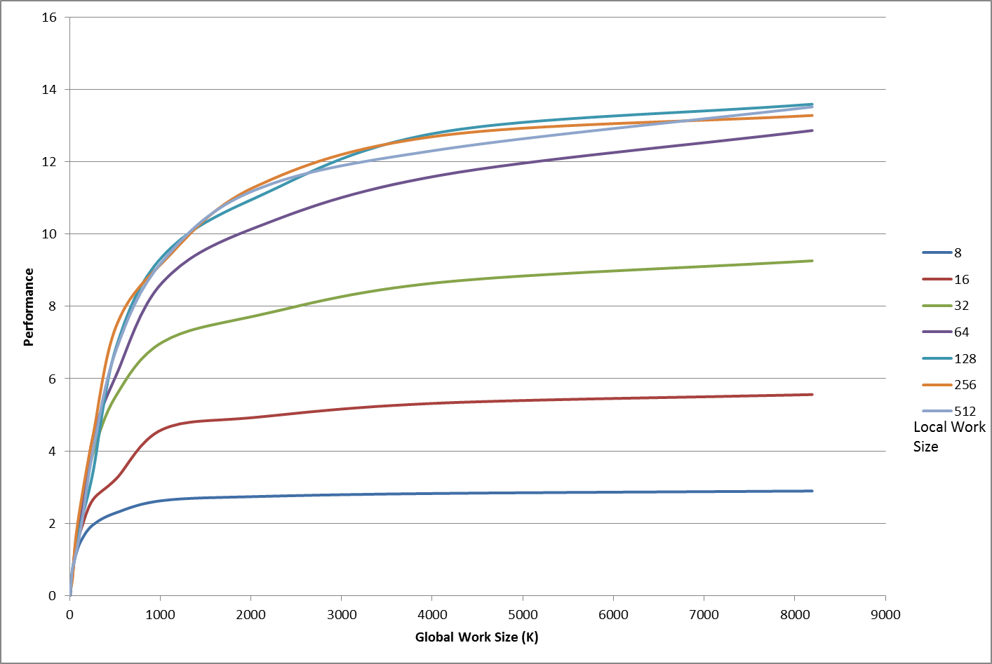

Fig 2. Multiplication Performance (MegaMultiplies/sec)

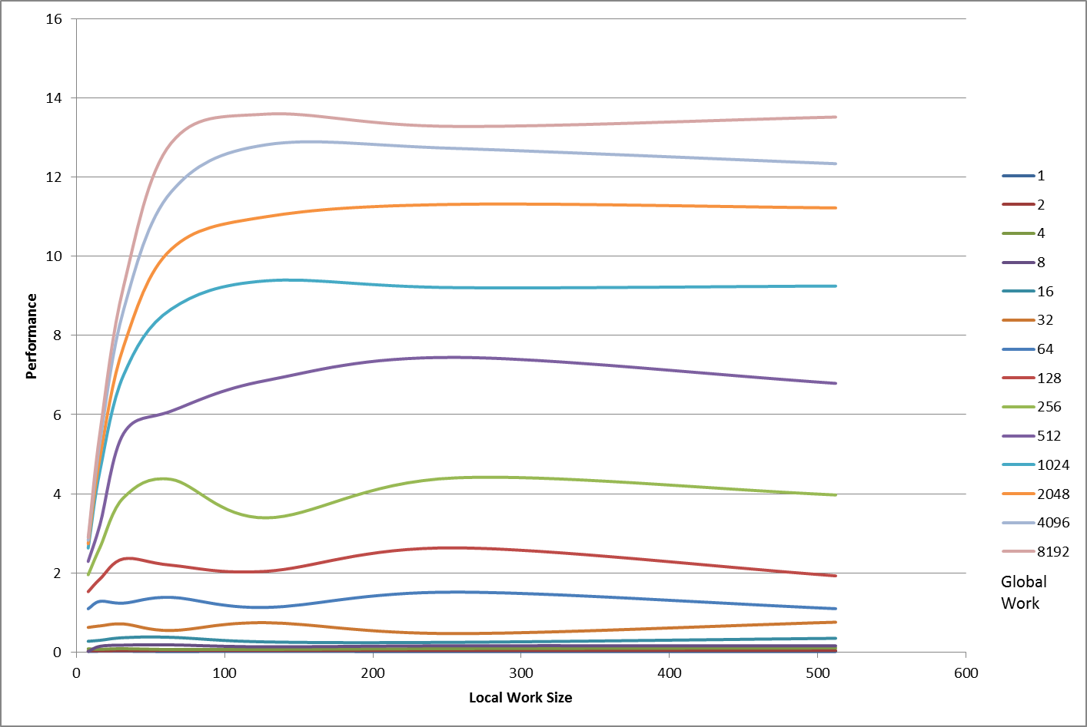

Fig 3. Multiplication (Transpose) Performance (MegaMultiplies/sec)

1. Multiplicatioin and Add Performance (MegaMultipliesAdd/sec)



Table II above represents the performance of Array Multiplication and Addition where performance is measured in MegaMultiplies/sec. The Global Work Size ranges from 1K to 8192K measured across the Local Work Size of 8, 16, 32, 64, 128, 256 and 512 respectively. The graphical representation of the table is shown in Fig 4 below. Here the performance varies with respect to the selected Local Work Size, where for Local work size of 8 shows a particularly low, but gradually increasing performance while the highest performance is observed with a local work size of 512. Here, the performance gradually increases with respect to the highest values of the Local Work Size and Global Work Size.

Fig 5 demonstrates the performance of Table II with a transpose representation of the graph in Fig 4. Here the performance is particularly observed with the respect to the Global Work Size while the horizontal axis represents the varying amount of the Local Work Size. From the particular figure it can be concluded that for Array Multiplication & Add using OpenCL, the highest performance gain is observed with the Global work size of 8192. Moreover, from the particular figure it can be observed that the performance levels to a constant (while gradually increasing or decreasing to that of the number of worksize) for both lower and higher values of Global Work Size.

These have been demonstrated with respect to Table I, Fig 2, and Fig 3 respectively.

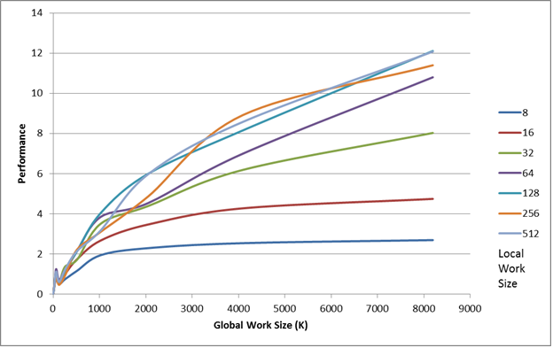

Fig 4. Multiplication and Add Performance(MegaMultiplies-Add/sec)

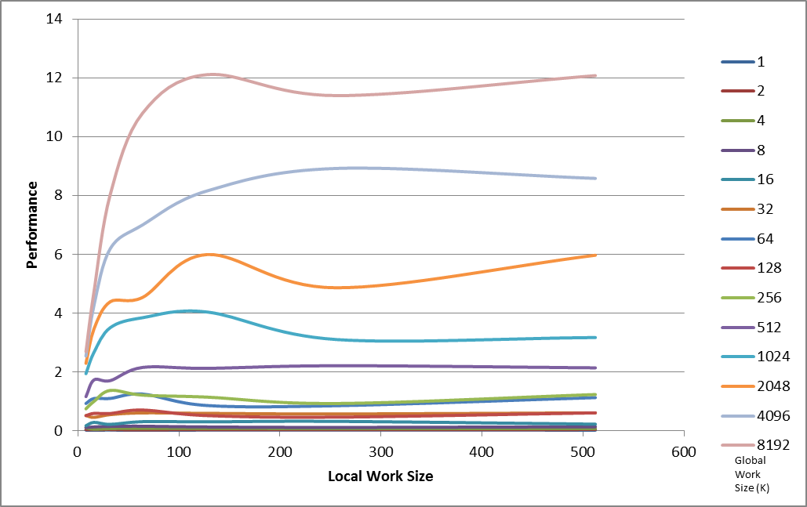

Fig 5. Multiplication and Add (Transpose) Performance(MegaMultiplies-Add/sec)

1. Reduction Performance (MegaMultipliesAdd/sec)



Table III above represents the performance of Array Multiplication and Reduction where performance is measured in MegaMultiplyReductions/sec. The Global Work Size ranges from 1K to 8192K measured across the Local Work Size of 32 respectively. The graphical representation of the table is shown in Fig 6 below. Here, a parabolic curve is observed with the increasing amount of Global work size to the constant Local work size. The highest performance is observed with respect to a Global Work Size of 8192.

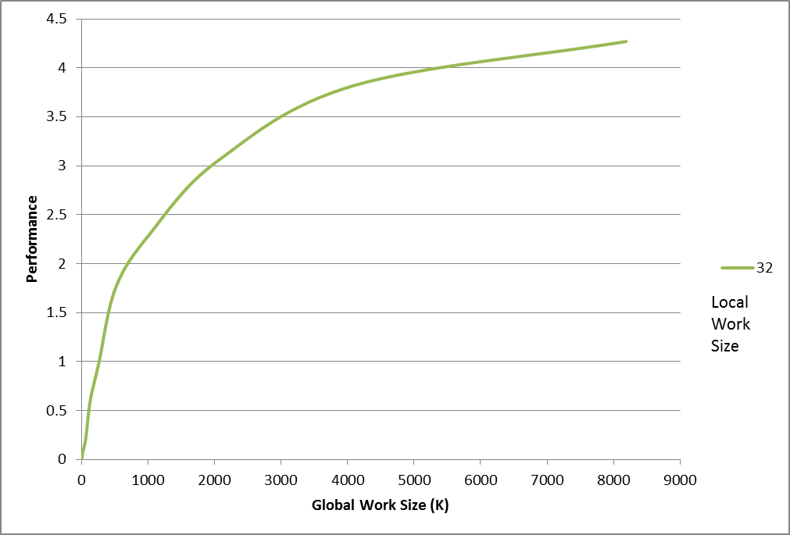

Fig 6. Multiplication and Reduction Performance (MegaMultiply-Reductions/sec)